Enterprise Agreement Voting
Opens 6am Monday 20th December
Closes 12 noon Wednesday 22nd December

Computers Available in Depot Training Room to complete your vote between the times of 2pm – 4pm, on
Monday 20th December,
Tuesday 21st December.

A City staff member will be available to assist with logging on to the system if you require it. Instructions on the following page on how to log in, or just scan the QR code.

You will need to enter your Surname, Employee Number (available on your payslip of contact Payroll/HR), and your Date of Birth

Voting is not compulsory
Elections Australia are managing the vote
The City only receives the total number of Yes and No votes

HOW TO VOTE ONLINE
You can vote from 6am, 20th December to 12 noon, 22nd December by following these steps.
- Log your computer on to the internet and in the address bar at the top left corner of your web browser (not through a search engine such as Google) enter myvote.com.au/busselton
OR you can scan your phone’s camera over the QR code shown here.
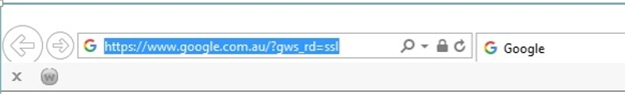

2. Enter your surname, employee number and date of birth then click on the submit button. 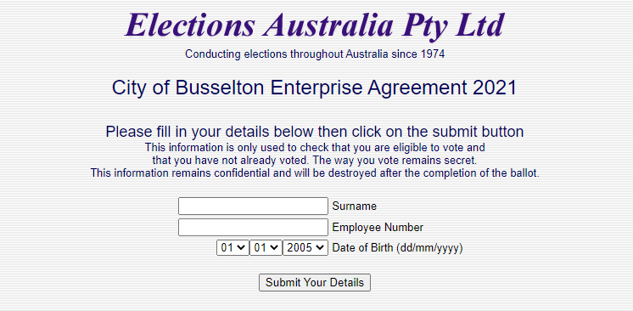

3. Click on either the YES or NO box then click on the submit button.
Once you click on SUBMIT you cannot change your vote
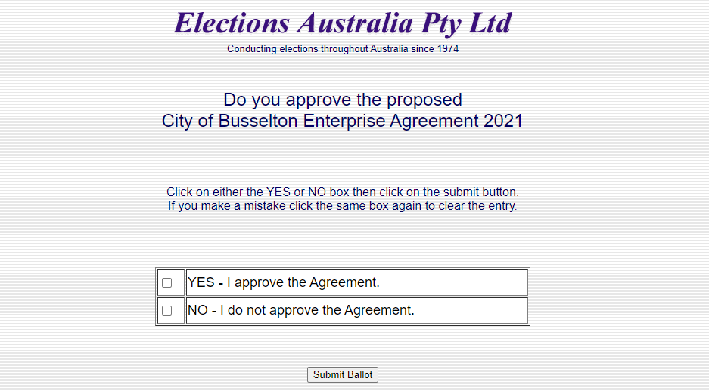

Please note that your personal information is only used to check that you are eligible to vote and that you have not already voted. The way you vote remains secret.

